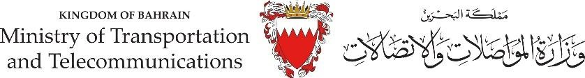

**APPLICATION OF PMA PASS**

# Port Passes Group

**PMA Passes Application Form**

The PMA pass is issued pursuant to the terms and conditions set out in the PMA Pass Conditions, the PMA Security, Safety, Health and Environmental Rules at the absolute discretion of Ports and Maritime Authority. Entry into PMA Facilities without a valid Pass constitutes an offence.

**INSTRUCTIONS TO THE APPLICANTS**

PMA Pass Applicant(s) need to provide following photocopies:

1. A letter by the Applicant’s Sponsor/ Sponsor’s letterhead addressed to Directorate of Security Affairs of PMA.
2. Sub- Tenants Application must provide a No Objection Latter from BLZ Directorate of PMA.
3. The Applicant’s (SMART CARD)
4. Passport (For Expatriate).
5. Work Permit (VISA).

**PHOTO**

1. Sponsor’s (CR).
2. One passport size photograph.

**PASS TYPE**

PERMANENT PASS (1 YEAR) TEMPORARY PASS (3 MONTHES)

**PURPOSE OF VISIT**

TENANT

SUB- TENANT CONTRACTOR DELIVERY

OTHER ( )

# APPCICANT’S PERSONAL INFORMATION

## NAME CPR

NATIONALITY CONTACT NO. COMPANY NAME OCCUPATION

**COMPANY’S STAMP FOR PMA USE ONLY**

## Checked and processed by:

PMA-SSD-01-PASS (Rev.1 - 22.6.2023)